"Colour is the attribute of visual experience that can be described as having quantitatively specifiable dimensions of hue, saturation, and brightness."
R. W. Burnham, R. M. Haynes and C. J. Bartleson, Colour: ‘A Guide to Basic Facts and Concepts’

The human eye is sensitive to monochromatic light in the range 380nm to 740nm. However, the sensitivity of the eye is not constant across this range. In particular, wavelengths below 400nm and above 700nm are not well received by the eye.
In the retina, there are two systems of receptors at work, the rods and the cones. The rods are sensitive to weak light, inoperative in strong light, and have maximum sensitivity at about 507nm. The cones are sensitive to strong light, insensitive to weak light, and have a maximum sensitivity at 555nm. Furthermore, there are three different types of cones present, each one more sensitive to a different primary colour, red, yellow or blue. Thus, it may be assumed that different people are likely to perceive the same colour differently. A universal standard for quantifying colour is therefor needed.
The properties of colour that are distinguishable by the human eye are hue, saturation, and brightness.
Hue: The hue of a colour is determined by the dominant wavelength or wavelengths; “red” and “blue” are primarily describing hue. It is convenient to arrange the saturated hues around a circle, and as such, most early colour systems were based on this format. However it
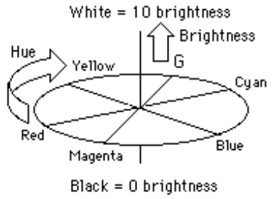
shows that not all hues can be represented by
spectral colours since there is no single
wavelength of light that has the magenta
hue - it may be produced by an equal mixture
of red and blue. Many different mixtures of
wavelengths can produce the same perceived
hue. The line through the centre of the
circle from black to grey to white represents light
that has no hue.
Saturation: A fully saturated colour is one that has no mixture of white. For example, pink has the same hue as red, but is less saturated. A colour consisting of only one wavelength is fully saturated, but one can have a fully saturated magenta, which is not a spectral colour. It must also be taken into consideration that certain hues may be perceived to be more saturated than others. For example, red and blue generally appear more saturated than yellow.
Brightness: The brightness of a coloured surface depends upon the illuminance of that surface, and it’s reflectivity. In other words, the more light that is incident upon a surface, and the more light that surface reflects, then obviously, the brighter that surface will appear. The wavelength of the incident light is also a key factor. For example, a red surface will appear brighter under a red light than a blue one.

